Community Group Leader Sync
November 15, 2016
“Leading in Weakness”

Worship: Zach Simons
Teaching: Josh Hughes
Testimony: Yaacov & Erin Petscher
Training: Scott Stake

Group Mission Opportunities:
- “Letting Go” Seminar & Book Release is this Saturday, November 19, 8:30am-12:15pm, at Four Oaks Killearn.
This event is for parents, pastors, ministry leaders, and anyone seeking to love and serve a wayward person. Four Oaks folks get FREE admission and book with code FOUROAKS.

- “The Skeptic Tank” is this Sunday, November 20, 6-8pm, at Four Oaks Midtown.
Invite questioning friends and neighbors!

- Killearn Connect Brunch is Sunday, December 4, during 1st service in Gallery 14!
We welcome CG leaders to come connect with guests! We also need a group to “sponsor” the brunch by bringing food items. Please let Scott know if you’d like to come or sponsor.

- Four Oaks Family Christmas is Sunday, December 4, 6-8pm, at Four Oaks Killearn.
Invite friends & neighbors to come. Also, make sure your group brings their assigned items.

- Mission Focus for 4Oaks Kids this December!
Families are encouraged to serve and be on mission this Christmas season. Look for ways to do this together as a community group!

- “An Evening in Nepal” is Thursday, December 8, at 6pm at Four Oaks Killearn
Come enjoy potluck dinner & hear our gospel partners Brian & Lois share about their ministry in Nepal and their heart for the Karmarong people. Childcare for nursery & prek is provided. Please RSVP at fouroakschurch.com!

- “Perspectives on the World Christian Movement” is a 15-week course starting Tuesday, January 17, 6:30-9pm, at Four Oaks Midtown.
Enjoy rich teaching from a diversity of church leaders & missionaries, outstanding readings, and a fun, dynamic learning environment. Sign up by December 4 at fouroakschurch.com/perspectives & save $50! You can take this course for college credit!

Other Announcements:
- Next Boot Camp Training begins in late January (by congregation)
Let Pastor Scott or Pastor Zach know if you or your apprentice would like to participate.

- Next Leader Sync is Monday, January 30, at 6pm; includes potluck & childcare.

- Men’s Retreat is Fri-Sat, Mar 31-Apr 1, at Camp Anderson!

- Redemption Groups launch is Saturday, April 8. We will then meet weekly on Monday nights from 6:30-9pm (childcare is available).

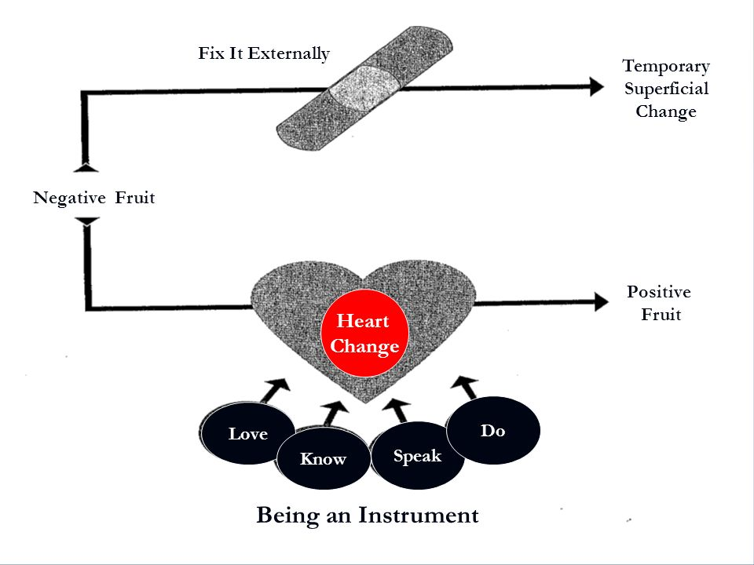

Instruments in the Redeemer’s Hands, Paul Tripp

